Austin Stephens

Assignment 01

1/21/16

Problem 05

My code successfully outputs my favorite quote from Theodore Roosevelt.

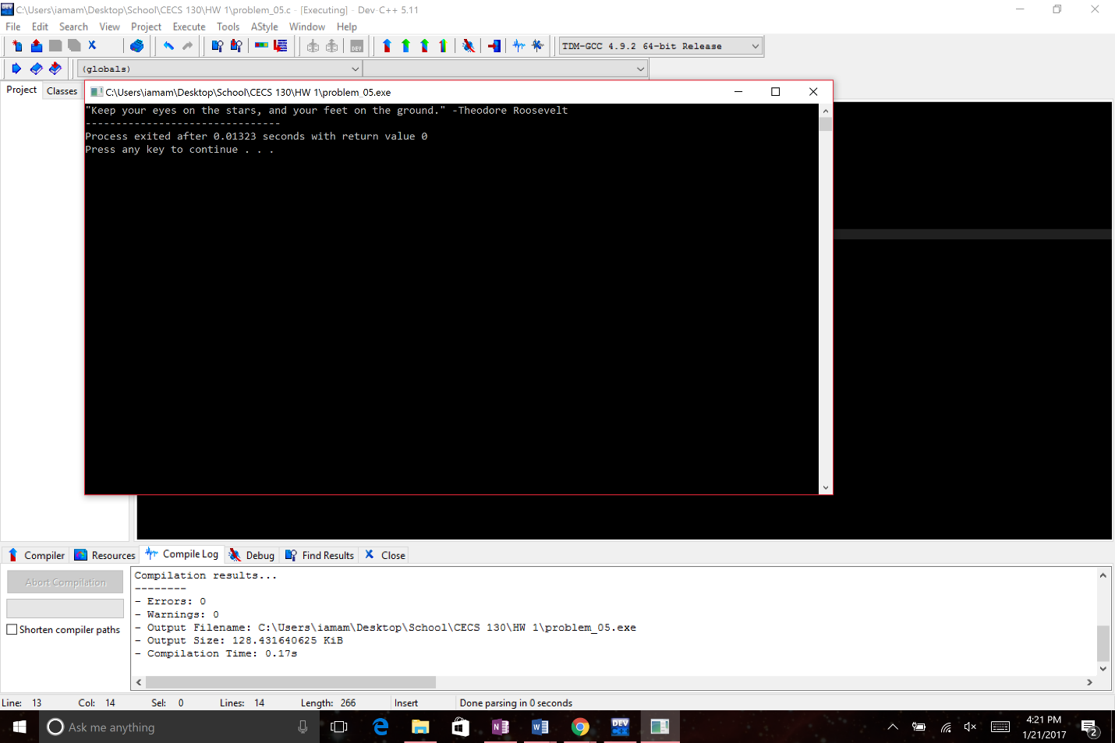

Problem 07

My code successfully prints out a diamond.

